What is data structure

It is a collection of values, the values can have relationship among them and function apply to them

Block chain is also just data structure

Readable, memory and speed – Three pillars of code

Two parts for data structure:

1. How to build one
2. How to use it

How computer store data

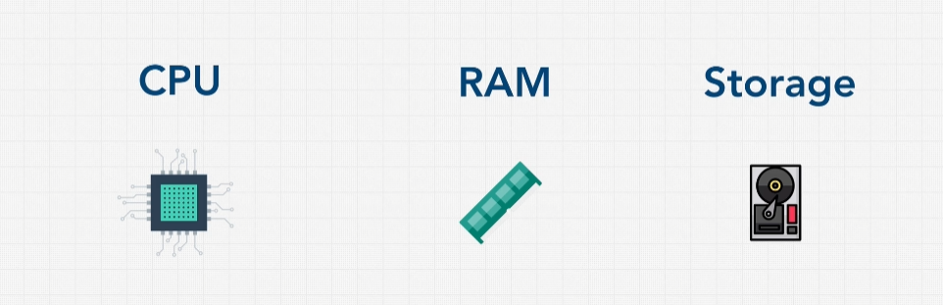

Variables stored in RAM. Data owned storage is permanent, or persistent.

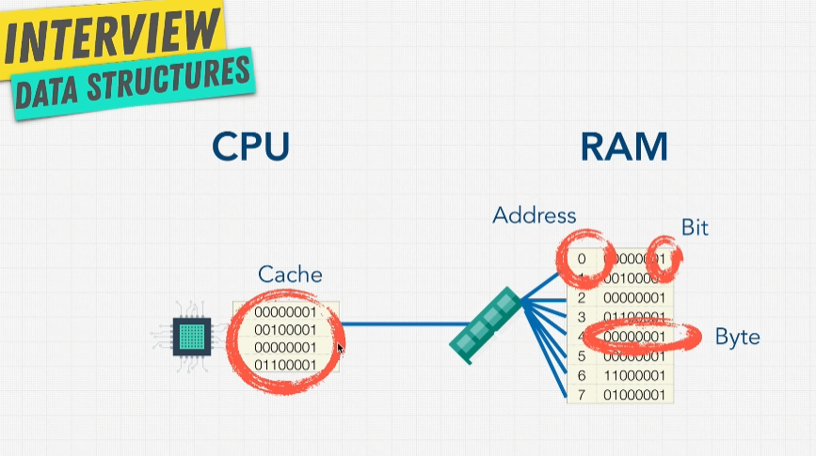

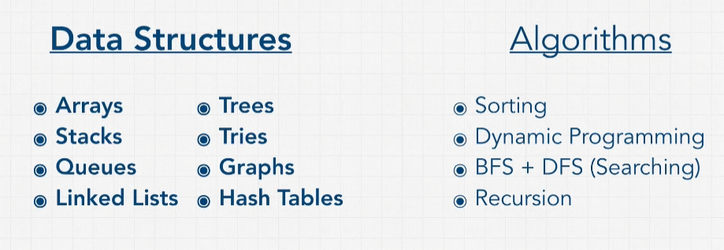

Operations on Data Structure

1. Insertion
2. Deletion
3. Traversal – Access each data exactly one by one
4. Searching
5. Sorting
6. Access

